Cloud Grocery Sales Data Pipeline

1. Project Overview

The Cloud Grocery Sales Data Pipeline is an end-to-end ETL project that extracts grocery order data from AWS S3, performs data transformation using Python and Pandas, loads processed data into PostgreSQL, and visualizes business insights using Power BI.

2. Objective

- Build a cloud-based ETL pipeline.
- Store data in AWS S3.
- Process data using Python.
- Load transformed data into PostgreSQL.
- Create business dashboards in Power BI.

3. Technologies Used

- Cloud:
- AWS S3
- IAM
- boto3
- Programming:
- Python
- Pandas
- Database:
- PostgreSQL
- SQLAlchemy
- Visualization:
- Power BI

4. Architecture

orders.csv
↓
AWS S3
↓
Python (boto3)
↓
Pandas ETL
↓
PostgreSQL
↓
Power BI Dashboard

5. Dataset Information

- Dataset:
- orders.csv

- Contains:
- 5000+ Orders
- 140 Columns
- Important Field:
- order_id
- order_dow
- order_hour_of_day
- days_since_prior_order
- day_name
- total_items

6. Extract Phase

Tasks:
- Created AWS S3 Bucket
- Uploaded dataset
- Created IAM User
- Generated Access Keys
- Connected AWS S3 using boto3

Example:
obj = s3.get_object(
Bucket="neel-orders-data-lake",
Key="orders.csv.csv"
)

7. Transform Phase

Data Profiling
Performed:
- Shape Analysis
- Column Analysis
- Null Value Analysis
- Statistical Analysis

Day Name Transformation
Created:
day_name
Example:
0 → Sunday
1 → Monday
...

Basket Analysis
Created:
total_items
by summing product quantities.

Product Category Analysis
Identified:
Top Selling Categories
Product Demand Patterns

8. Load Phase

Loaded transformed data into PostgreSQL.
Example:
df.to_sql(
"orders",
engine,
if_exists="replace",
index=False
)

9. SQL Analysis

Total Orders
SELECT COUNT(*) FROM orders;

Orders by Day
SELECT day_name, COUNT(*) FROM orders
GROUP BY day_name;

Average Basket Size
SELECT AVG(total_items) FROM orders;

Orders by Hour
SELECT order_hour_of_day, COUNT(*) FROM orders
GROUP BY order_hour_of_day;

10. Power BI Dashboard

KPI Cards
- Total Orders
- Average Basket Size
- Peak Order Hour
- Average Days Between Orders
Charts
- Orders by Day
- Orders by Hour
- Average Basket Size by Day
- Reorder Interval Distribution

11. Key Insights

Example:
- Sunday recorded the highest number of orders.
- Average basket size was approximately 10 items.
- Most orders were placed during afternoon hours.
- Many customers reordered after approximately 30 days.

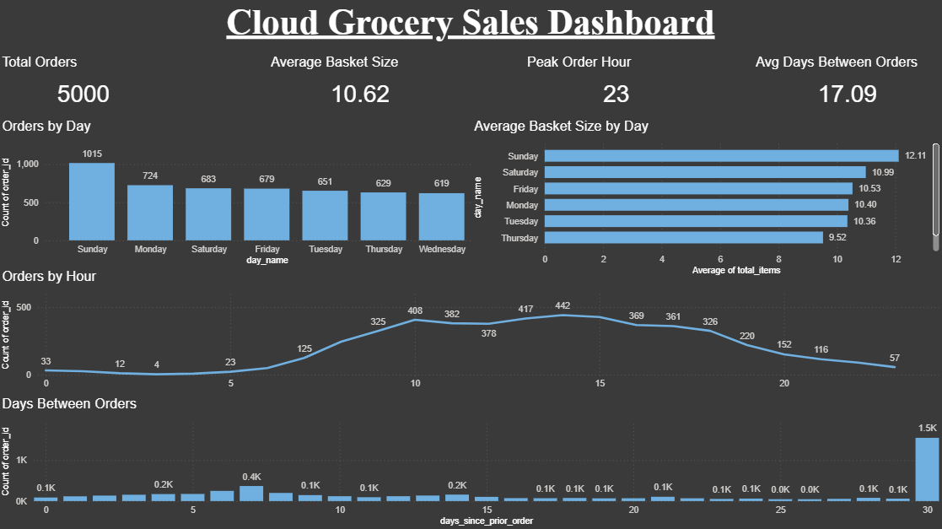

12. Business Benefits

- Understand customer purchasing behaviours.
- Analyze order frequency patterns.
- Identify high-demand product categories.
- Support inventory planning and sales analysis.

13. AWS S3 and IAM Implementation

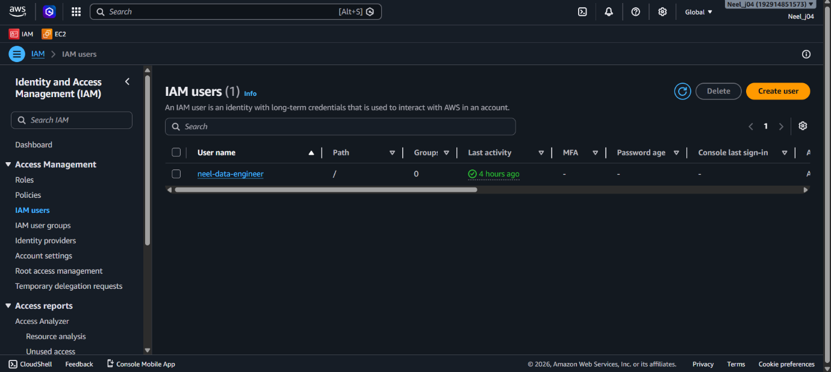

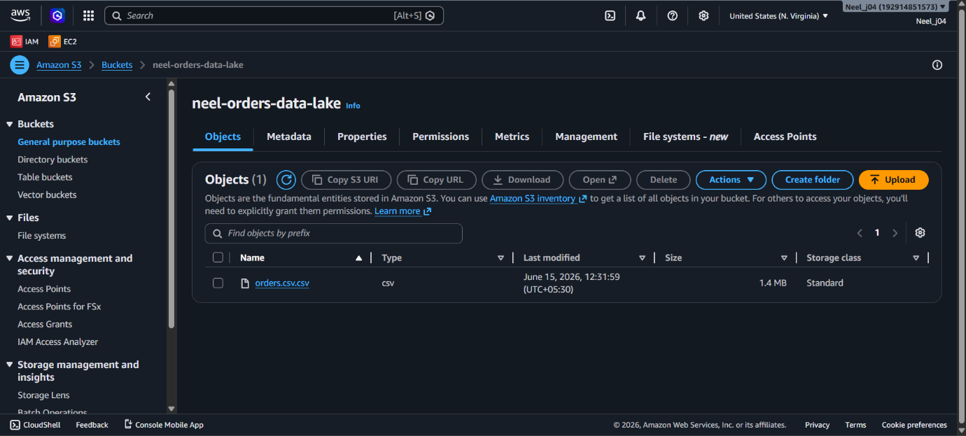
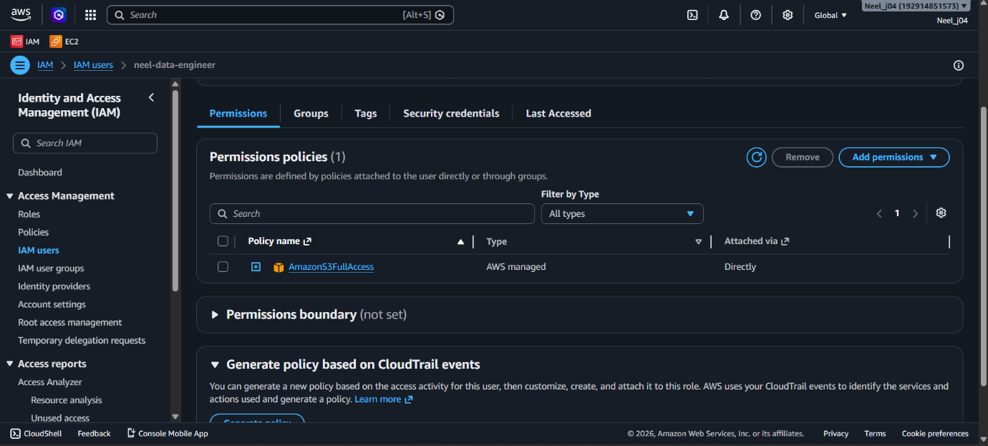

14. Conclusion

Successfully developed a cloud-based ETL pipeline using AWS S3, Python, PostgreSQL, SQL, and Power BI. The project demonstrates practical cloud data engineering skills including cloud storage, data ingestion, transformation, database loading, analytics, and dashboard development.

